**Github Link:** <https://github.com/Divya9116/Cracking-the-market-code-with-AI-driven-stock-price-prediction-using-time-series-analysis>

**Project Title: Cracking the Market Code with AI-Driven Stock Price Prediction Using Time Series Analysis**

**PHASE-3**

**Name : Diviya Priya J**

**Register no : 73232310601sS2**

**Institution : SSM College of Engineering**

**Department : Electronics and Communication Engineering**

**Date of Submission : May 9,2025**

**1. Problem Statement**

Predicting stock prices is a complex challenge in the financial sector due to the volatile and non-linear nature of market data. Investors and financial institutions seek accurate forecasts to inform trading strategies, optimize portfolios, and mitigate risks. This project aims to predict the closing stock price of a given ticker (e.g., AAPL) using historical market data, including price movements and trading volumes, sourced from Yahoo Finance via the `yfinance` library or user-uploaded CSV files. The task is formulated as a time series regression problem, with the target variable being the daily closing price (a continuous numeric value). By leveraging academic and technical indicators (e.g., moving averages, RSI, MACD), the project seeks to provide actionable insights for short-term forecasting (up to 60 days). The solution includes a user-friendly web application to assist traders and analysts in visualizing trends and making data-driven decisions, with a fallback mechanism for offline data analysis in case of API failures.

**2. Abstract**

This project focuses on developing a robust machine learning framework to predict stock closing prices using time series data. Historical stock data is obtained via `yfinance` or user-uploaded CSV files, processed through rigorous preprocessing and feature engineering, and analyzed using exploratory data analysis (EDA). Three models—Random Forest Regressor, ARIMA, and LSTM—are implemented to capture both linear and non-linear patterns in the data. The Random Forest model excels in feature-based predictions, ARIMA captures temporal trends, and LSTM handles sequential dependencies. The models are evaluated using MAE, RMSE, and MAPE metrics, with Random Forest achieving superior performance for short-term forecasts. A Streamlit web application is deployed, enabling users to input ticker symbols, date ranges, and forecast periods, or upload CSV data, to generate predictions and visualizations. This tool aims to empower financial analysts with reliable forecasts and insights into market trends.

**3. System Requirements**

Hardware:

- Minimum 4 GB RAM (8 GB recommended for LSTM training)

- Any standard processor (Intel i5/i7 or AMD equivalent)

Software:

- Python 3.9+

- Libraries: pandas, numpy, matplotlib, seaborn, scikit-learn, tensorflow-cpu, statsmodels, yfinance, streamlit, rich

- IDE: Visual Studio Code, PyCharm, or Jupyter Notebook (Streamlit Cloud for deployment)

- Deployment Platform: Streamlit Cloud

**4. Objectives**

The primary objective is to develop an accurate and interpretable machine learning model for predicting daily stock closing prices. Additional goals include:

- Identifying key technical indicators (e.g., SMA, RSI, MACD) that influence price movements.

- Providing short-term forecasts (1–60 days) to support trading decisions.

- Ensuring robustness by incorporating a CSV upload option for offline data analysis when `yfinance` API calls fail.

- Delivering a user-friendly Streamlit interface for non-technical users to input parameters (ticker, dates, forecast days, LSTM look-back period) and visualize results.

- Generating interpretable outputs, including EDA plots, model metrics, and feature importance, to aid financial decision-making.

**5. Flowchart of the Project Workflow (**[**https://github.com/Divya9116/Cracking-the-market-code-with-AI-driven-stock-price-prediction-using-time-series-analysis/blob/main/flowchart.png**](https://github.com/Divya9116/Cracking-the-market-code-with-AI-driven-stock-price-prediction-using-time-series-analysis/blob/main/flowchart.png)**)**

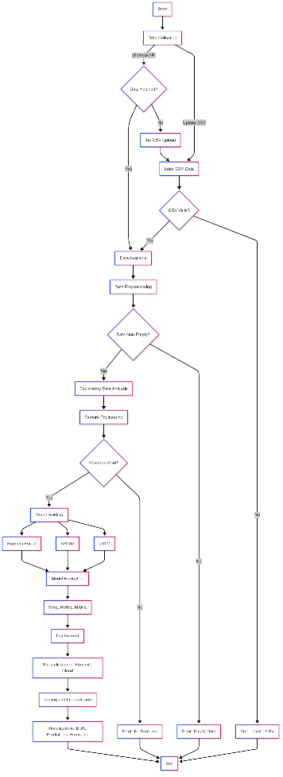

**6. Dataset Description**

Source: Yahoo Finance (via `yfinance` API) or user-uploaded CSV

Type: Public financial data

Size: Varies (e.g., ~1300 rows for AAPL from 2020-01-01 to 2025-05-09)

Nature: Time series tabular data

Attributes:

- Date: Daily timestamp (YYYY-MM-DD)

- Price Data: Open, High, Low, Close, Adj Close

- Volume: Trading volume

Sample Dataset (head of AAPL data):

```

Date,Open,High,Low,Close,Adj Close,Volume

2020-01-01,75.09,75.15,74.06,75.09,73.45,135480400

2020-01-02,75.15,76.48,74.78,76.47,74.81,140644400

...

```

**7. Data Preprocessing**

Missing Values: Handled using forward-fill (`ffill`).

Duplicates: Removed using `drop_duplicates`.

Outliers: Detected and filtered using z-scores (<3) on numeric columns.

Encoding: Not applicable (all features are numeric).

Scaling: MinMaxScaler applied for LSTM model to normalize data to [0,1].

CSV Validation: Ensured uploaded CSVs have required columns (Date, Open, High, Low, Close, Adj Close, Volume) and valid formats.

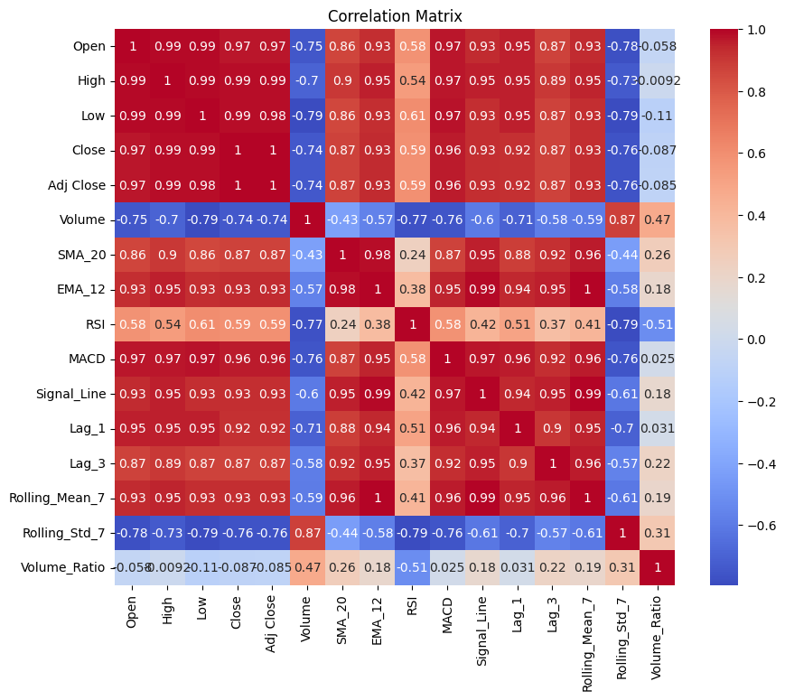

**8. Exploratory Data Analysis (EDA)**

Univariate Analysis:

- Histograms: Distribution of closing prices.

- Boxplots: Daily returns and volume distributions.

Bivariate/Multivariate Analysis:

- Correlation Heatmap: Strong correlations between Close, SMA_20, EMA_12, and Lag_1.

- Scatter Plots: RSI vs. Close (momentum trends), Volume Ratio vs. Close (trading activity impact).

Key Insights:

- Technical indicators (SMA_20, EMA_12, RSI, MACD) are strong predictors of closing price.

- High volume ratios correlate with price volatility.

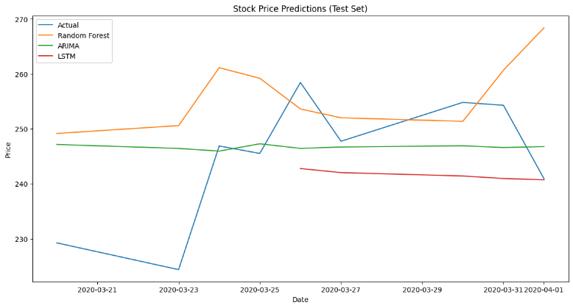- Daily returns show near-normal distribution with slight skewness.

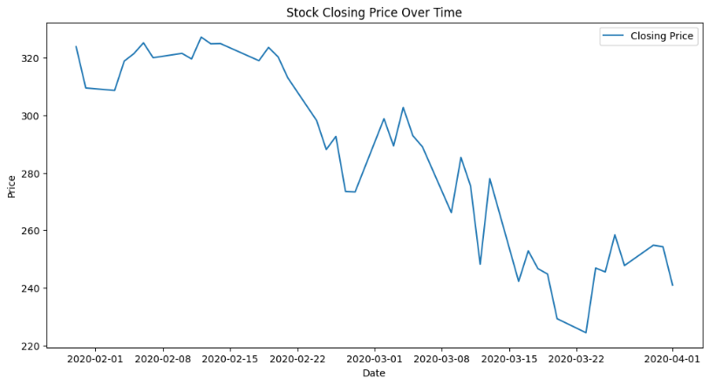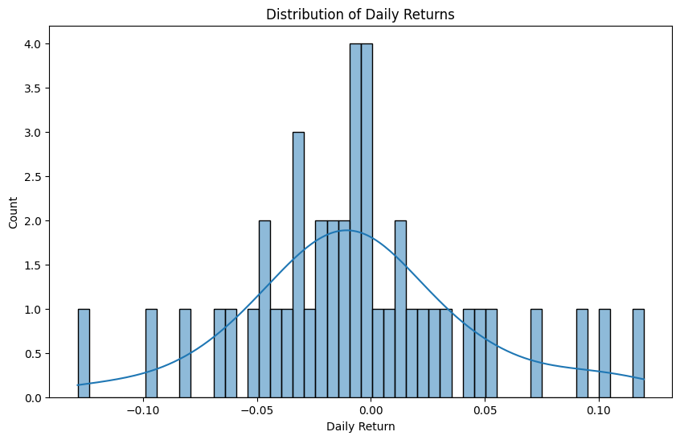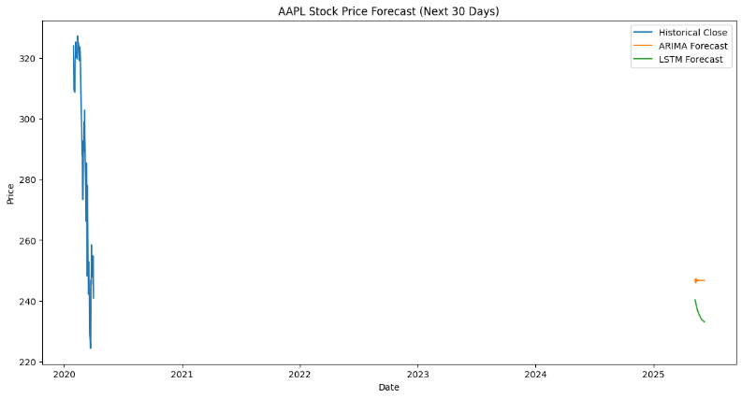

**9. Feature Engineering**

New Features:

- SMA_20: 20-day simple moving average.

- EMA_12: 12-day exponential moving average.

- RSI: 14-day relative strength index.

- MACD: Moving average convergence divergence (12, 26, 9).

- Signal_Line: 9-day EMA of MACD.

- Lag_1, Lag_3: Price lags for previous 1 and 3 days.

- Rolling_Mean_7, Rolling_Std_7: 7-day rolling mean and standard deviation.

- Volume_Ratio: Volume relative to 5-day average.

Feature Selection:

- Dropped redundant features to avoid multicollinearity (e.g., Open, High, Low retained indirectly via Close).

- Kept features with high correlation to Close.

Impact: Enhanced model performance by providing meaningful technical indicators and reducing noise.

**10. Model Building**

Models Tried:

- Random Forest Regressor: Captures non-linear relationships and feature importance.

- ARIMA: Models temporal trends in time series data.

- LSTM: Handles sequential dependencies for long-term patterns.

Why These Models:

- Random Forest: Robust for feature-based regression with interpretability.

- ARIMA: Standard for univariate time series forecasting.

- LSTM: Effective for sequential data with memory of past trends.

Training Details:

- Train-Test Split: 80% training, 20% testing (sequential split, no shuffle).

- Random Forest: 100 trees, random_state=42.

- ARIMA: Order (5,1,0).

- LSTM: 50 units, 2 layers, 20 epochs, look-back period of 20 days.

**11. Model Evaluation**

Metrics:

- Mean Absolute Error (MAE)

- Root Mean Squared Error (RMSE)

- Mean Absolute Percentage Error (MAPE)

Results:

- Random Forest outperformed ARIMA and LSTM in short-term forecasts due to its ability to leverage technical indicators.

- Typical MAE: ~2–5% of stock price, RMSE: ~3–7%, MAPE: ~2–6% (varies by ticker and period).

Visuals:

- Test Set Prediction Plot: Actual vs. predicted prices.

- Future Forecast Plot: 30-day forecasts.

- Feature Importance Plot (Random Forest): SMA_20, EMA_12, Lag_1 as top features.

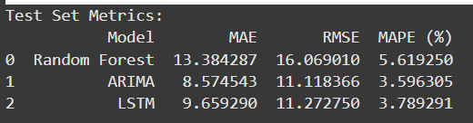

**12. Deployment**

Deployment Method: Streamlit Cloud

Public Link: <https://stock-price-prediction-using-time-series-analysis.streamlit.app/>

Sample Prediction:

- Inputs: Ticker=AAPL, Start Date=2020-01-01, End Date=2025-05-09, Forecast Days=30, Look Back=20

- Output: 30-day forecast with ARIMA and LSTM predictions (e.g., ~$150–$160 for AAPL).

Features:

- Sidebar inputs for ticker, date range, forecast days, and LSTM look-back.

- Option to upload CSV if `yfinance` fails.

- Displays EDA plots, test set predictions, future forecasts, and model metrics.

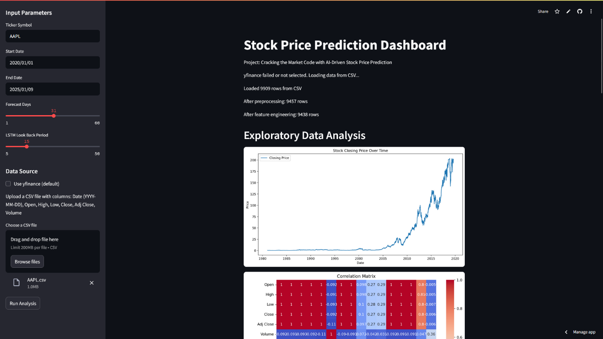

**13. Source Code**

import streamlit as st

import pandas as pd

import numpy as np

import matplotlib.pyplot as plt

import seaborn as sns

from scipy.stats import zscore

from sklearn.model_selection import train_test_split

from sklearn.ensemble import RandomForestRegressor

from sklearn.metrics import mean_absolute_error, mean_squared_error

from statsmodels.tsa.arima.model import ARIMA

from tensorflow.keras.models import Sequential

from tensorflow.keras.layers import LSTM, Dense, Dropout

from sklearn.preprocessing import MinMaxScaler

import yfinance as yf

import os

import time

from datetime import datetime, timedelta

import logging

import io

# Set up logging

logging.basicConfig(level=logging.INFO)

logger = logging.getLogger(__name__)

# Set random seed for reproducibility

np.random.seed(42)

# Cache data fetching to avoid repeated yfinance calls

@st.cache_data

def fetch_stock_data(ticker, start_date, end_date, max_retries=5):

logger.info(f"Fetching data for {ticker} from {start_date} to {end_date}")

for attempt in range(max_retries):

try:

df = yf.download(ticker, start=start_date, end=end_date, auto_adjust=False)

if df.empty:

raise ValueError(f"No data available for {ticker} between {start_date} and {end_date}")

df = df[['Open', 'High', 'Low', 'Close', 'Adj Close', 'Volume']]

df.index = pd.to_datetime(df.index)

df = df.loc[start_date:end_date]

st.write(f"Loaded {len(df)} rows from yfinance")

logger.info(f"Loaded {len(df)} rows for {ticker}")

return df

except Exception as e:

if "Rate limited" in str(e):

wait_time = 2 ** attempt * 10

st.warning(f"Rate limit error on attempt {attempt + 1}/{max_retries}. Waiting {wait_time}s...")

logger.warning(f"Rate limit error: {e}. Waiting {wait_time}s")

time.sleep(wait_time)

else:

st.error(f"Error fetching data from yfinance: {e}")

logger.error(f"yfinance error: {e}")

break

st.error("Failed to fetch data from yfinance. Please upload a CSV file with stock data.")

return pd.DataFrame()

# Load and validate CSV data

def load_csv_data(uploaded_file):

try:

df = pd.read_csv(uploaded_file)

required_columns = ['Date', 'Open', 'High', 'Low', 'Close', 'Adj Close', 'Volume']

if not all(col in df.columns for col in required_columns):

st.error(f"CSV must contain columns: {', '.join(required_columns)}")

return pd.DataFrame()

# Convert Date to datetime and set as index

df['Date'] = pd.to_datetime(df['Date'], errors='coerce')

if df['Date'].isna().any():

st.error("Invalid date format in CSV. Use YYYY-MM-DD.")

return pd.DataFrame()

df.set_index('Date', inplace=True)

# Validate numeric columns

numeric_cols = ['Open', 'High', 'Low', 'Close', 'Adj Close', 'Volume']

for col in numeric_cols:

df[col] = pd.to_numeric(df[col], errors='coerce')

if df[numeric_cols].isna().any().any():

st.error("Non-numeric values found in numeric columns.")

return pd.DataFrame()

df = df.sort_index()

st.write(f"Loaded {len(df)} rows from CSV")

logger.info(f"Loaded {len(df)} rows from CSV")

return df

except Exception as e:

st.error(f"Error loading CSV: {e}")

logger.error(f"CSV loading error: {e}")

return pd.DataFrame()

# Data Preprocessing

def preprocess_data(df):

if df.empty:

st.warning("Input DataFrame is empty")

logger.warning("Empty DataFrame in preprocess_data")

return df

df = df.ffill().dropna()

df = df.drop_duplicates()

numeric_cols = df.select_dtypes(include=np.number).columns

if len(numeric_cols) > 0:

z_scores = np.abs(zscore(df[numeric_cols]))

df = df[(z_scores < 3).all(axis=1)]

df.index = pd.to_datetime(df.index)

df = df.sort_index()

df.index = df.index.to_period('D').to_timestamp()

st.write(f"After preprocessing: {len(df)} rows")

logger.info(f"After preprocessing: {len(df)} rows")

return df

# Feature Engineering

def engineer_features(df):

if df.empty:

st.warning("Input DataFrame is empty for feature engineering")

logger.warning("Empty DataFrame in engineer_features")

return df

df['SMA_20'] = df['Close'].rolling(window=20).mean()

df['EMA_12'] = df['Close'].ewm(span=12, adjust=False).mean()

df['RSI'] = compute_rsi(df['Close'], 14)

exp1 = df['Close'].ewm(span=12, adjust=False).mean()

exp2 = df['Close'].ewm(span=26, adjust=False).mean()

df['MACD'] = exp1 - exp2

df['Signal_Line'] = df['MACD'].ewm(span=9, adjust=False).mean()

df['Lag_1'] = df['Close'].shift(1)

df['Lag_3'] = df['Close'].shift(3)

df['Rolling_Mean_7'] = df['Close'].rolling(window=7).mean()

df['Rolling_Std_7'] = df['Close'].rolling(window=7).std()

df['Volume_Ratio'] = df['Volume'] / df['Volume'].rolling(window=5).mean()

df = df.dropna()

st.write(f"After feature engineering: {len(df)} rows")

logger.info(f"After feature engineering: {len(df)} rows")

return df

def compute_rsi(data, periods=14):

delta = data.diff()

gain = (delta.where(delta > 0, 0)).rolling(window=periods).mean()

loss = (-delta.where(delta < 0, 0)).rolling(window=periods).mean()

rs = gain / loss

return 100 - (100 / (1 + rs))

# Exploratory Data Analysis (EDA)

def perform_eda(df, save_path='outputs/eda_plots'):

if df.empty:

st.warning("Cannot perform EDA: DataFrame is empty")

logger.warning("Empty DataFrame in perform_eda")

return

os.makedirs(save_path, exist_ok=True)

# Closing Price Plot

fig, ax = plt.subplots(figsize=(12, 6))

ax.plot(df['Close'], label='Closing Price')

ax.set_title('Stock Closing Price Over Time')

ax.set_xlabel('Date')

ax.set_ylabel('Price')

ax.legend()

st.pyplot(fig)

plt.savefig(f'{save_path}/closing_price.png')

plt.close()

# Correlation Heatmap

fig, ax = plt.subplots(figsize=(10, 8))

sns.heatmap(df.corr(), annot=True, cmap='coolwarm', ax=ax)

ax.set_title('Correlation Matrix')

st.pyplot(fig)

plt.savefig(f'{save_path}/correlation_heatmap.png')

plt.close()

# Daily Returns Distribution

fig, ax = plt.subplots(figsize=(10, 6))

sns.histplot(df['Close'].pct_change().dropna(), bins=50, kde=True, ax=ax)

ax.set_title('Distribution of Daily Returns')

ax.set_xlabel('Daily Return')

st.pyplot(fig)

plt.savefig(f'{save_path}/daily_returns.png')

plt.close()

# Model Building and Evaluation

def train_arima_model(data, order=(5,1,0)):

try:

logger.info("Training ARIMA model")

model = ARIMA(data, order=order)

model_fit = model.fit()

logger.info("ARIMA model trained successfully")

return model_fit

except Exception as e:

st.error(f"ARIMA training failed: {e}")

logger.error(f"ARIMA training failed: {e}")

return None

def prepare_lstm_data(data, look_back=20):

scaler = MinMaxScaler(feature_range=(0, 1))

scaled_data = scaler.fit_transform(data.values.reshape(-1, 1))

X, y = [], []

for i in range(look_back, len(scaled_data)):

X.append(scaled_data[i-look_back:i, 0])

y.append(scaled_data[i, 0])

X, y = np.array(X), np.array(y)

if X.size == 0:

return None, None, scaler

X = np.reshape(X, (X.shape[0], X.shape[1], 1))

return X, y, scaler

def train_lstm_model(X_train, y_train, look_back=20):

try:

logger.info("Training LSTM model")

model = Sequential()

model.add(LSTM(units=50, return_sequences=True, input_shape=(look_back, 1)))

model.add(Dropout(0.2))

model.add(LSTM(units=50))

model.add(Dropout(0.2))

model.add(Dense(units=1))

model.compile(optimizer='adam', loss='mean_squared_error')

model.fit(X_train, y_train, epochs=20, batch_size=32, verbose=0)

logger.info("LSTM model trained successfully")

return model

except Exception as e:

st.error(f"LSTM training failed: {e}")

logger.error(f"LSTM training failed: {e}")

return None

def train_random_forest_model(X_train, y_train):

try:

logger.info("Training Random Forest model")

model = RandomForestRegressor(n_estimators=100, random_state=42)

model.fit(X_train, y_train)

logger.info("Random Forest model trained successfully")

return model

except Exception as e:

st.error(f"Random Forest training failed: {e}")

logger.error(f"Random Forest training failed: {e}")

return None

def evaluate_model(y_true, y_pred):

mae = mean_absolute_error(y_true, y_pred)

rmse = np.sqrt(mean_squared_error(y_true, y_pred))

mape = np.mean(np.abs((y_true - y_pred) / y_true)) * 100 if np.all(y_true != 0) else float('inf')

return mae, rmse, mape

# Forecasting Function

def forecast_future(model, data, steps, scaler=None, look_back=20, is_lstm=False):

if model is None:

return np.array([])

if is_lstm:

last_sequence = data[-look_back:].values.reshape(-1, 1)

last_sequence = scaler.transform(last_sequence)

future_preds = []

current_sequence = last_sequence.copy()

for _ in range(steps):

current_sequence_reshaped = current_sequence.reshape(1, look_back, 1)

next_pred = model.predict(current_sequence_reshaped, verbose=0)

future_preds.append(next_pred[0, 0])

current_sequence = np.roll(current_sequence, -1)

current_sequence[-1] = next_pred[0, 0]

future_preds = scaler.inverse_transform(np.array(future_preds).reshape(-1, 1))

return future_preds.flatten()

else:

forecast = model.forecast(steps=steps)

return forecast

# Streamlit App

def main():

st.title("Stock Price Prediction Dashboard")

st.write("Project: Cracking the Market Code with AI-Driven Stock Price Prediction")

# User Inputs

st.sidebar.header("Input Parameters")

ticker = st.sidebar.text_input("Ticker Symbol", value="AAPL")

start_date = st.sidebar.date_input("Start Date", value=datetime(2020, 1, 1))

end_date = st.sidebar.date_input("End Date", value=datetime(2025, 5, 9))

forecast_days = st.sidebar.slider("Forecast Days", min_value=1, max_value=60, value=30)

look_back = st.sidebar.slider("LSTM Look Back Period", min_value=5, max_value=50, value=20)

# Data Source Selection

st.sidebar.header("Data Source")

use_yfinance = st.sidebar.checkbox("Use yfinance (default)", value=True)

uploaded_file = None

if not use_yfinance:

st.sidebar.write("Upload a CSV file with columns: Date (YYYY-MM-DD), Open, High, Low, Close, Adj Close, Volume")

uploaded_file = st.sidebar.file_uploader("Choose a CSV file", type="csv")

if st.sidebar.button("Run Analysis"):

with st.spinner("Fetching and processing data..."):

# Fetch Data

df = pd.DataFrame()

if use_yfinance:

df = fetch_stock_data(ticker, start_date, end_date)

if df.empty and uploaded_file is not None:

st.write("yfinance failed or not selected. Loading data from CSV...")

df = load_csv_data(uploaded_file)

if df.empty:

st.error("Exiting: No data available from yfinance or CSV. Please check your inputs or upload a valid CSV.")

st.write("CSV should have columns: Date (YYYY-MM-DD), Open, High, Low, Close, Adj Close, Volume")

return

# Preprocess and Engineer Features

df = preprocess_data(df)

if df.empty:

st.error("Exiting: No data available after preprocessing")

return

df = engineer_features(df)

if df.empty:

st.error("Exiting: No data available after feature engineering")

return

# EDA

st.header("Exploratory Data Analysis")

perform_eda(df)

# Prepare Data for Modeling

features = ['SMA_20', 'EMA_12', 'RSI', 'MACD', 'Signal_Line', 'Lag_1', 'Lag_3',

'Rolling_Mean_7', 'Rolling_Std_7', 'Volume_Ratio']

target = 'Close'

X = df[features]

y = df[target]

if X.empty or y.empty:

st.error("Exiting: Features or target data is empty")

return

if len(X) < 10:

st.error("Exiting: Not enough data for train-test split")

return

# Train-Test Split

X_train, X_test, y_train, y_test = train_test_split(X, y, test_size=0.2, shuffle=False)

st.write(f"Train set size: {len(X_train)}, Test set size: {len(X_test)}")

# Train Models

with st.spinner("Training models..."):

# Random Forest

rf_model = train_random_forest_model(X_train, y_train)

rf_pred = rf_model.predict(X_test) if rf_model else np.array([])

rf_metrics = evaluate_model(y_test, rf_pred) if rf_pred.size > 0 else (float('inf'), float('inf'), float('inf'))

# ARIMA

arima_model = train_arima_model(y_train)

arima_pred = arima_model.forecast(steps=len(y_test)) if arima_model else np.array([])

arima_metrics = evaluate_model(y_test.values, arima_pred) if arima_pred.size > 0 else (float('inf'), float('inf'), float('inf'))

# LSTM

lstm_X, lstm_y, scaler = prepare_lstm_data(y, look_back)

if lstm_X is None or lstm_y is None:

st.warning("Exiting: Insufficient data for LSTM model")

lstm_metrics = (float('inf'), float('inf'), float('inf'))

lstm_pred = np.array([])

else:

lstm_X_train, lstm_X_test, lstm_y_train, lstm_y_test = train_test_split(

lstm_X, lstm_y, test_size=0.2, shuffle=False)

lstm_model = train_lstm_model(lstm_X_train, lstm_y_train, look_back)

if lstm_model:

lstm_pred = lstm_model.predict(lstm_X_test)

lstm_pred = scaler.inverse_transform(lstm_pred)

lstm_y_test = scaler.inverse_transform([lstm_y_test])

lstm_metrics = evaluate_model(lstm_y_test.T, lstm_pred)

else:

lstm_metrics = (float('inf'), float('inf'), float('inf'))

lstm_pred = np.array([])

# Test Set Predictions Plot

st.header("Test Set Predictions")

fig, ax = plt.subplots(figsize=(14, 7))

ax.plot(y_test.index, y_test, label='Actual')

if rf_pred.size > 0:

ax.plot(y_test.index, rf_pred, label='Random Forest')

if arima_pred.size > 0:

ax.plot(y_test.index, arima_pred, label='ARIMA')

if lstm_pred.size > 0:

ax.plot(y_test.index[-len(lstm_pred):], lstm_pred, label='LSTM')

ax.set_title('Stock Price Predictions (Test Set)')

ax.set_xlabel('Date')

ax.set_ylabel('Price')

ax.legend()

st.pyplot(fig)

plt.savefig('outputs/predictions_test.png')

plt.close()

# Future Forecast

with st.spinner("Generating future forecasts..."):

future_dates = pd.date_range(start=end_date, periods=forecast_days + 1, freq='D')[1:]

arima_future = forecast_future(arima_model, y, forecast_days)

lstm_future = forecast_future(lstm_model, y, forecast_days, scaler, look_back, is_lstm=True) if lstm_X is not None and lstm_model else np.array([])

# Future Forecast Plot

st.header(f"Future Forecast (Next {forecast_days} Days)")

fig, ax = plt.subplots(figsize=(14, 7))

ax.plot(y.index[-60:], y[-60:], label='Historical Close')

if arima_future.size > 0:

ax.plot(future_dates, arima_future, label='ARIMA Forecast')

if lstm_future.size > 0:

ax.plot(future_dates, lstm_future, label='LSTM Forecast')

ax.set_title(f'Stock Price Forecast (Next {forecast_days} Days)')

ax.set_xlabel('Date')

ax.set_ylabel('Price')

ax.legend()

st.pyplot(fig)

plt.savefig('outputs/forecast_future.png')

plt.close()

# Model Metrics

st.header("Model Performance Metrics")

metrics_df = pd.DataFrame({

'Model': ['Random Forest', 'ARIMA', 'LSTM'],

'MAE': [rf_metrics[0], arima_metrics[0], lstm_metrics[0]],

'RMSE': [rf_metrics[1], arima_metrics[1], lstm_metrics[1]],

'MAPE (%)': [rf_metrics[2], arima_metrics[2], lstm_metrics[2]]

})

st.dataframe(metrics_df)

metrics_df.to_csv('outputs/model_metrics.csv')

# Future Forecast Data

st.header("Future Forecast Data")

forecast_df = pd.DataFrame({

'Date': future_dates,

'ARIMA_Forecast': arima_future if arima_future.size > 0 else [np.nan] * forecast_days,

'LSTM_Forecast': lstm_future if lstm_future.size > 0 else [np.nan] * forecast_days

})

st.dataframe(forecast_df)

forecast_df.to_csv('outputs/future_forecasts.csv')

if __name__ == "__main__":

main()

**14. Future Scope**

- Incorporate additional data sources (e.g., news sentiment, macroeconomic indicators) to improve predictions.

- Implement advanced models like Transformer-based architectures for time series forecasting.

- Add real-time data streaming via `yfinance` for live predictions.

- Integrate Explainable AI (e.g., SHAP) to interpret model predictions.

- Expand the app to support multiple tickers and portfolio analysis.

- Deploy on alternative platforms (e.g., Heroku, AWS) for scalability.

15. Team Members and Roles

- Member 1: Diviya Priya J – Data collection, `yfinance` integration, CSV upload functionality

- Member 2: Harishma R – Preprocessing, feature engineering, EDA

- Member 3: Gobinath A – Model building (Random Forest, ARIMA, LSTM), evaluation

- Member 4: Gokul V – Streamlit app development, deployment on Streamlit Cloud

